**Problem Statement:**

You have successfully cleared your fifth semester. In the final semester you will work with views, transactions and exception handling.

**Tasks To Be Performed:**

1. Create a view named ‘customer_san_jose’ which comprises of only those customers who are from San Jose.

**Snapshot :**

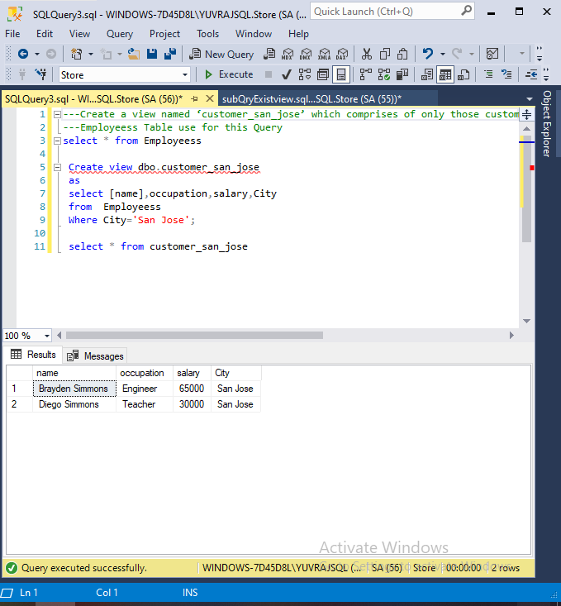

1. Inside a transaction, update the first name of the customer to Francis where the last name is Jordan:

**Snapshot:**

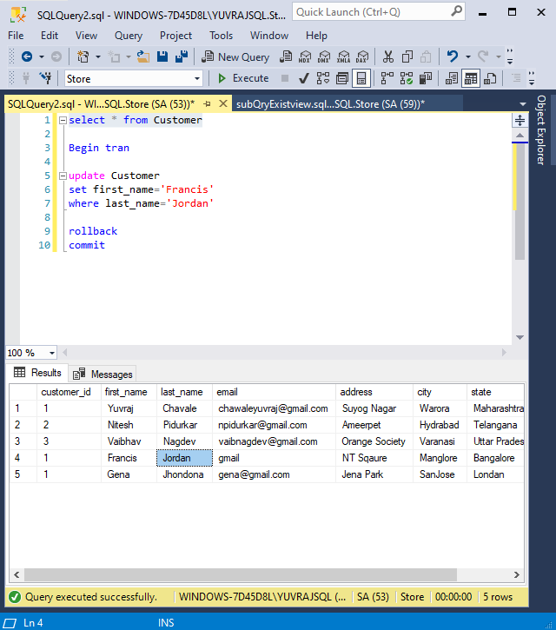

1. Rollback the transaction .

**Snapshot:**

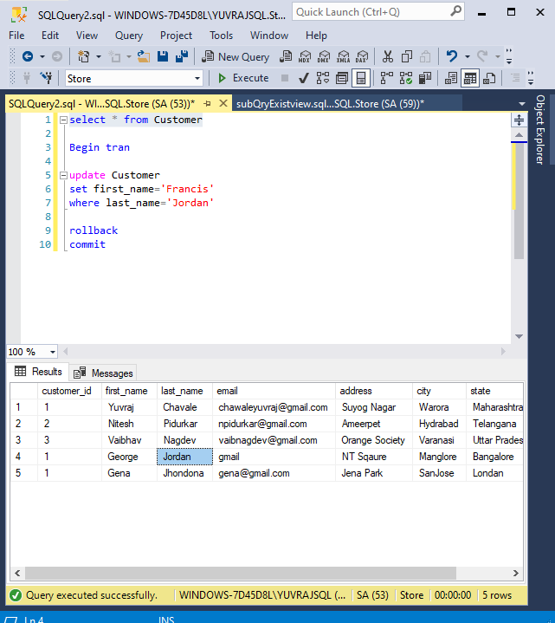

1. Set the first name of customer to Alex, where the last name is Jordan.

**Snapshot :**

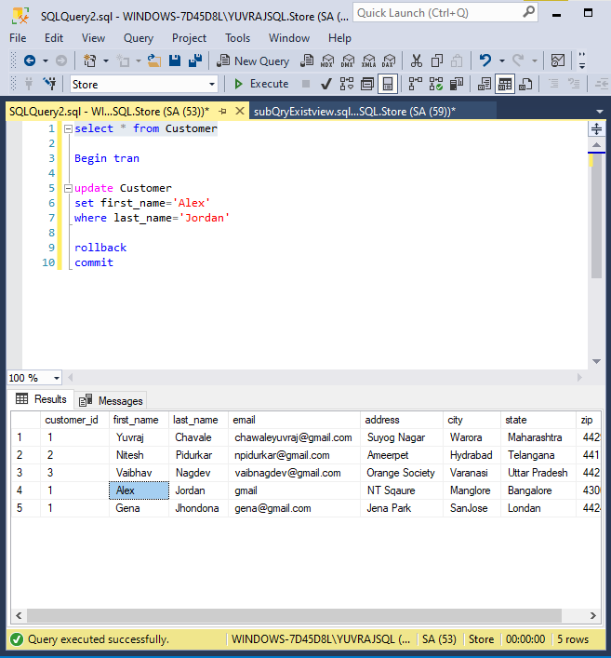

1. Inside a TRY... CATCH block, divide 100 with 0, print the default error message.

**Snapshot:**

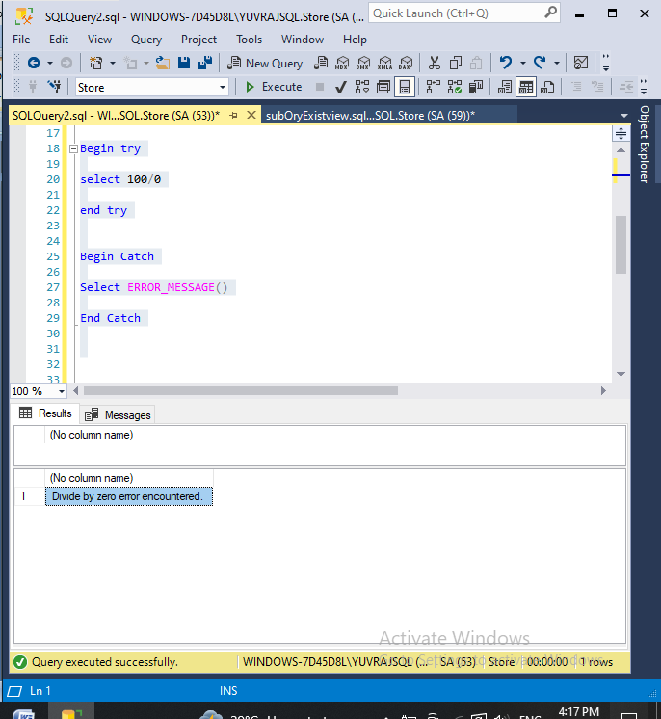

1. Create a transaction to insert a new record to Orders table and save it.

**Snapshot:**

